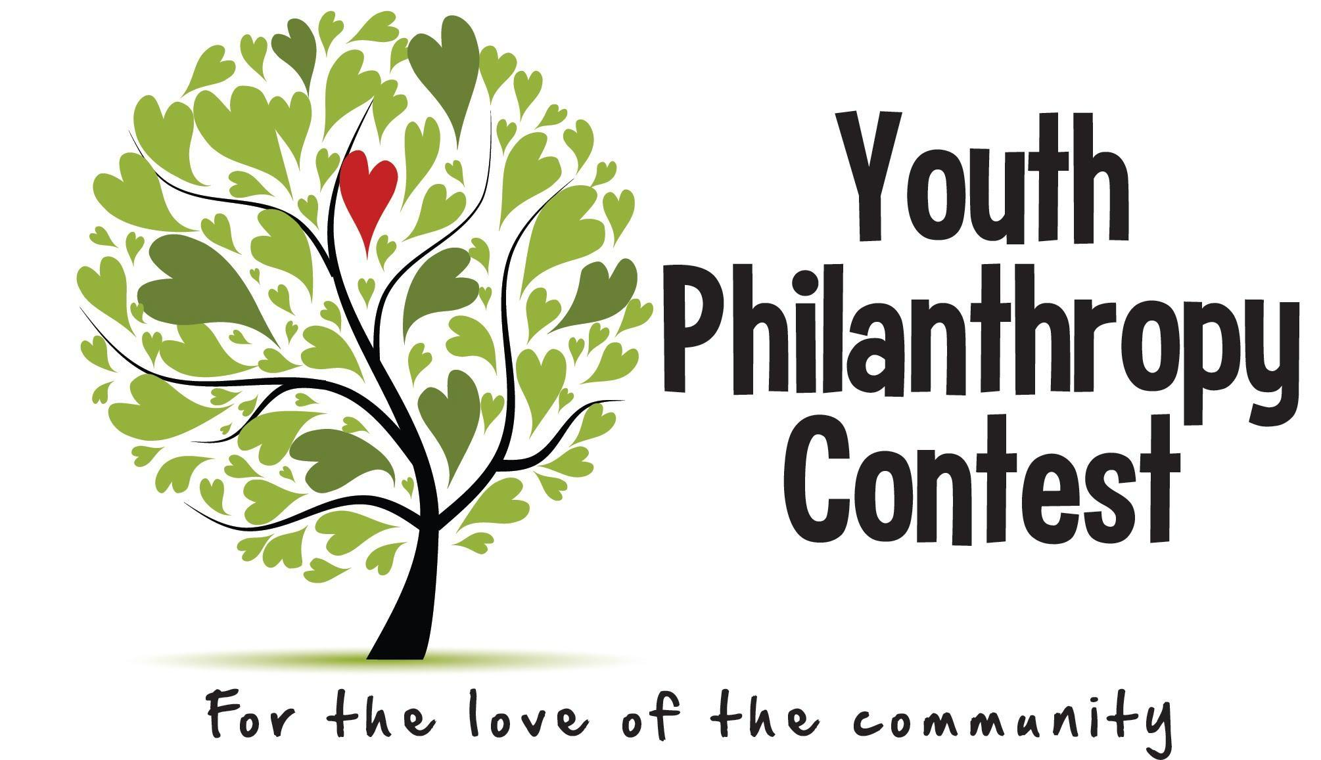
YOUTH PHILANTHROPY CONTEST 2023 FINAL REPORT
Important Dates:
June 9, 2023 – 4 month report due
October 1, 2023 – Final report due

Congratulations on a job well done! We are so excited to hear all about your project and its implementation. Please complete the information below and return your completed report by email to youthcontest@philanthropycouncilne.org or to the Philanthropy Council at PO Box 714, Norfolk NE 68702
by October 1, 2023. Please send photos via email.

Project Name: ______________________________________________________________________________________
Group Name (if applicable): _________________________________________________________________________
Primary Project Contact Name: ________________________________________________________________________
Mentor(s): _________________________________________________________________________________________
Community Partner Organization: _____________________________________________________________________

1. What impact did your project have in the community?

2. Describe who your project served (please include ages, number of people, ethnic populations etc.).

3. Did you meet any unexpected challenges during the project? If so, how did you handle them?

4. Describe what you (and your group, if you were a part of one) learned through this process.

5. What went really well? What would you do differently if you were to do it again?

6. Will this project/program continue after this? If so, how?

7. Did you interact with your mentors during the process? How were the mentors helpful, or not helpful, as you did your project?

Initial Projected Budget: _________________ Actual Final Expenses: _________________________
Have actual costs been consistent with estimates? If not, what were the reasons for the variances?

8. Please recount how you spent the money for your project:
ITEM COST
_________________________________ ________________________________

_________________________________ ________________________________

_________________________________ ________________________________

_________________________________ ________________________________

_________________________________ ________________________________

_________________________________ ________________________________

TOTAL EXPENSES TO-DATE: _____________ Balance Remaining from contest funds: _______________

9. Any final thoughts to share with the Youth Philanthropy Contest Committee as we prepare for next year’s event?

