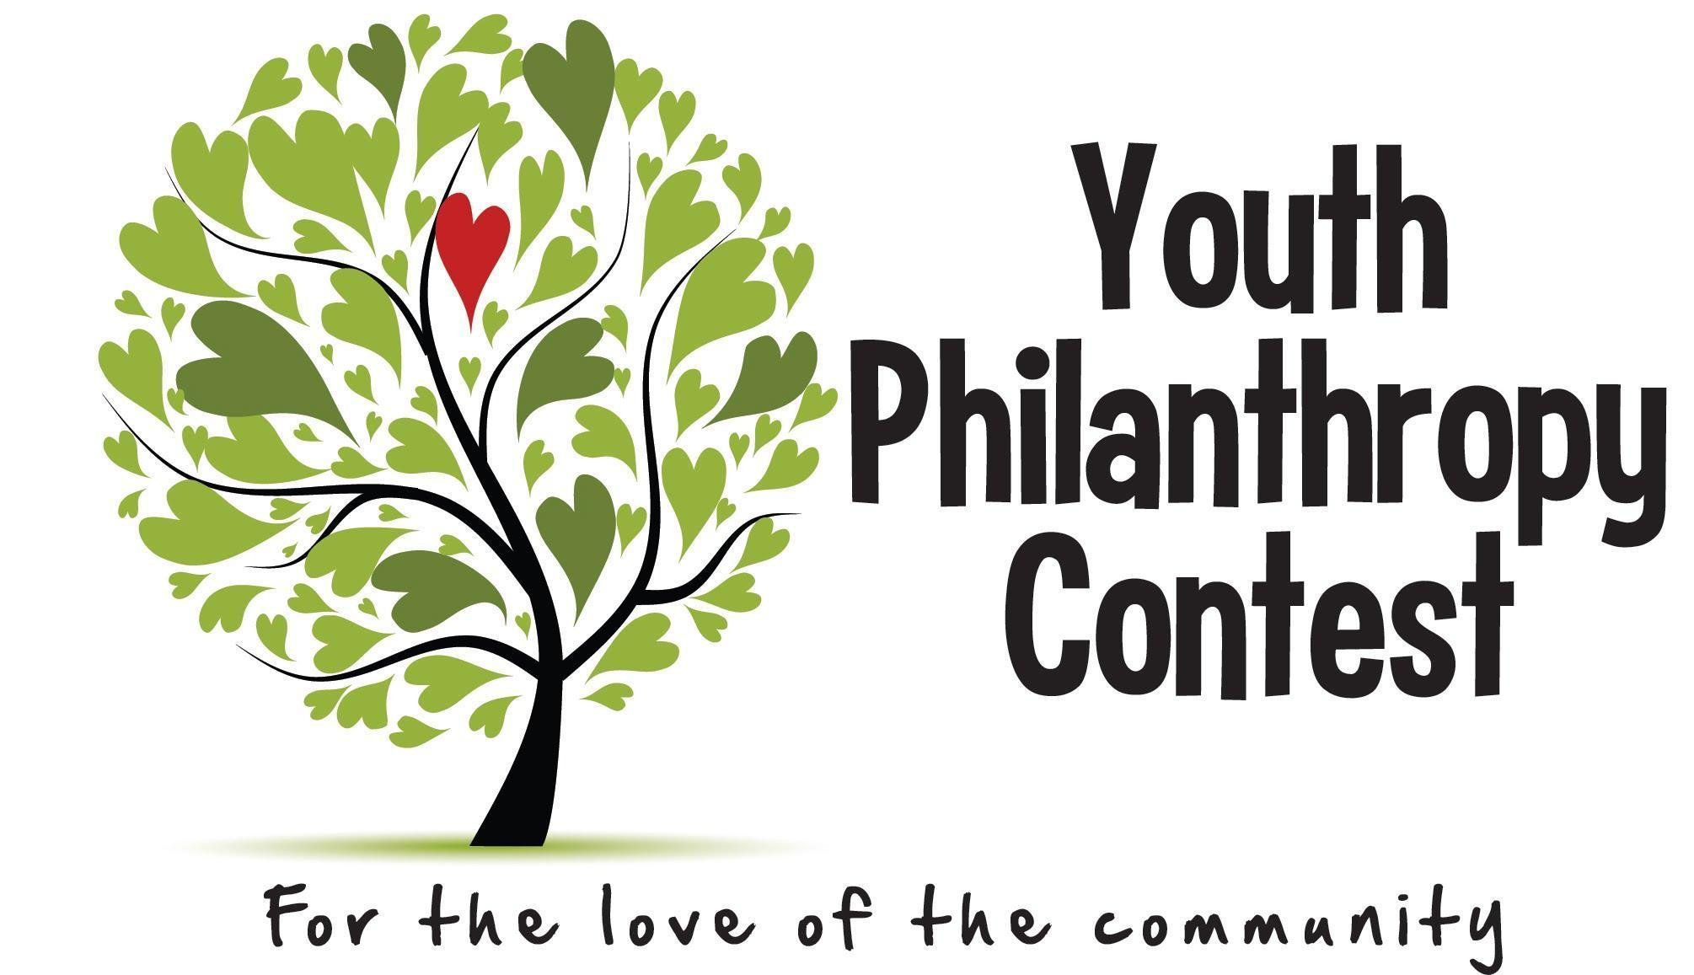
YOUTH PHILANTHROPY CONTEST 2023
Important Dates:
June 9th, 2023 – 4 month report due
October 1st, 2023– Final report due

FOUR MONTH REPORT

Please complete the information below and return your completed report by email to youthcontest@philanthropycouncilne.org or the Philanthropy Council at:
PO Box 714, Norfolk NE 68702 by June 9th, 2023.
***If you have already completed your project, you may skip this form and go directly to the Final Report.

Project Name: _ ________________________________________________ ______________
Group Name (if applicable): __________________________________________________________________________
Primary Project Contact Name: __ _________________________ _________________
Mentor(s): _ _________________________________________________________________________
Community Partner Organization: _ _____________________________________________________

- Please provide a brief summary of your project’s progress. What have you completed so far?

- What do you have left to do for your project to be complete?

- When do you anticipate your project will be fully completed?

- Please list the expenses you have had so far:
ITEM COST
_ _________________ ________________ _________
_ _________________________ ________________________
_________________________________ ________________________________
_________________________________ ________________________________
_________________________________ ________________________________
_________________________________ ________________________________

TOTAL EXPENSES TO-DATE: ____________

5. Any questions, concerns, or suggestions you would like to share with the Youth Philanthropy Contest Committee at this time?

