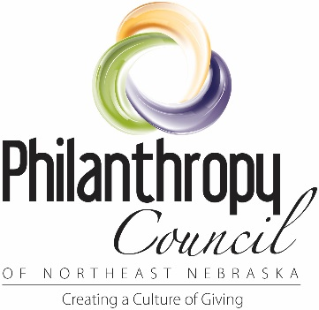
Philanthropy Council of Northeast Nebraska
Collaborative Partner Application

Participation in the Philanthropy Council is open to staff, volunteers and board members of 501c3 non-profit organizations in Northeast Nebraska who are interested in supporting the mission of the Philanthropy Council, which is to Create a Culture of Giving.

Benefits of Partnership
- Opportunities to combine resources and efforts to promote a culture of giving in northeast Nebraska and encourage giving back to local non-profits.
- Monthly meetings with directors and other area non-profit staff, volunteers, and board members to discuss issues, share information, network, and partner to raise awareness on giving opportunities in our communities.
- Coordinated events, informational sessions, and mailings focused on educating area residents on ways in which they can give something back to their favorite non-profits.
- Access to best practice information on a variety of areas important to area non-profits such as fundraiser, board development, strategic planning, volunteer management, endowment building, resource development, and planned giving.
- Partnership opportunities with other area non-profits.
- Participation in the Celebrate Giving events and Youth Philanthropy Contest.
- Participation in the Big Give fundraising day.
- Partner rates on all trainings
- Listing in the Non-Profit Resource Guide, Philanthropy Council Website, and all marketing and publicity of the organization.

Fee Structure
Philanthropy Council partners come from a variety of organizations with many different configurations of staff and volunteers and a wide range of operational budgets. With this in mind, the suggested fee structure is tailored to fit the size of each organization. Each organization should determine their individual fee based on these suggested dollar amounts and each individual organization’s circumstances. Partnership funds support the efforts of the Philanthropy Council in the community, which is an investment in the future of your organization and the people it serves.
Suggested Partnership Rates are:
Annual Operating Budget $0 - $50,000 = $50 dues
$50,001 - $500,000 = $100 dues
$500,001 – 1 million = $150 dues
$1,000,001+ = $200 dues

Non-partners are always welcome to attend monthly meetings and work with the organization on its mission, Creating a Culture of Giving, but will not be listed in publications or promotional materials.

Partner Organization Information Sheet
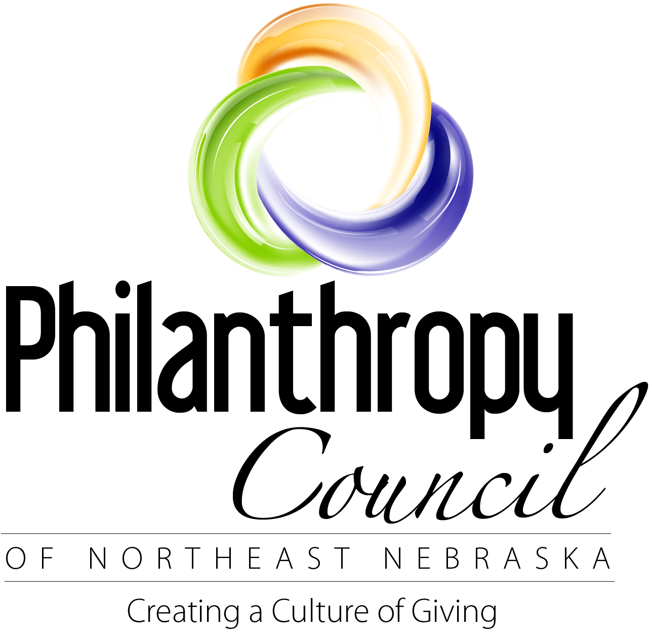
**The information on this page will be used for internal organization purposes. It will not be published on the website. For the website information please complete the accompanying pages titled “Website Resource Guide “. Thanks.

Organization Name:
Organization Mailing Address:
Organization Physical Address:
Organization Phone Number: Fax:
Organization Website:
Director of Organization:
Primary Contact Email for Organization:
Partnership Level:
*If your organization is unable to fit into one of the above levels, please contact the Philanthropy Council Chair.
Organization’s Mission:
Population & Area Served:
Are you a 501(c)3 organization?

Philanthropy Council Participant Information
Please provide contact information for anyone from your organization who would like to participate in the Philanthropy Council. This might include the Executive Director, volunteers, board members, staff, etc.
Name: Work Phone:
Mailing Address: Cell Phone:
Email address:

Name: Work Phone:
Mailing Address: Cell Phone:
Email address:

Name: Work Phone:
Mailing Address: Cell Phone:
Email address:

**Please attach additional contact information and people as needed.

Website Resource Guide
The information included on this form will be published on the Philanthropy Council website under the “Giving Back” tab. It will be viewable by potential donors visiting our website. Please email this form and information to info@philanthropycouncilne.org if you have it available electronically.
Organization Legal Name:
Organization Public Name (if different from legal name):
Organization Mailing Address:
Organization Physical Address:
Organization Phone Number: Fax:
Contact Email for Organization:
Director of Organization:
Organization Website address:
Organization’s Mission:
Brief Description of What Your Organization Does:
Population/Area Served and their basic demographics:
Organization’s Needs/Wish List:
Number of Staff: Number of Board Members:
Year Established: Estimated Number of Regular Volunteers:
Does your organization have an established endowment(s)? Please list all endowments, their purposes, and amount in accounts and expectancies:
Does your organization have an active endowment building plan/campaign?

Please include the following with your response if you have them:
- Bequest language Organization logo Information about ways to give to your organization
- Planned giving materials (brochures, forms, policies, etc.)
- Photos of your organization that you would like to include online
- Your organization’s marketing pieces (brochures, flyers, pledge cards, annual reports, etc.)
- Statistics about the impact of your services on the people of Northeast Nebraska.

