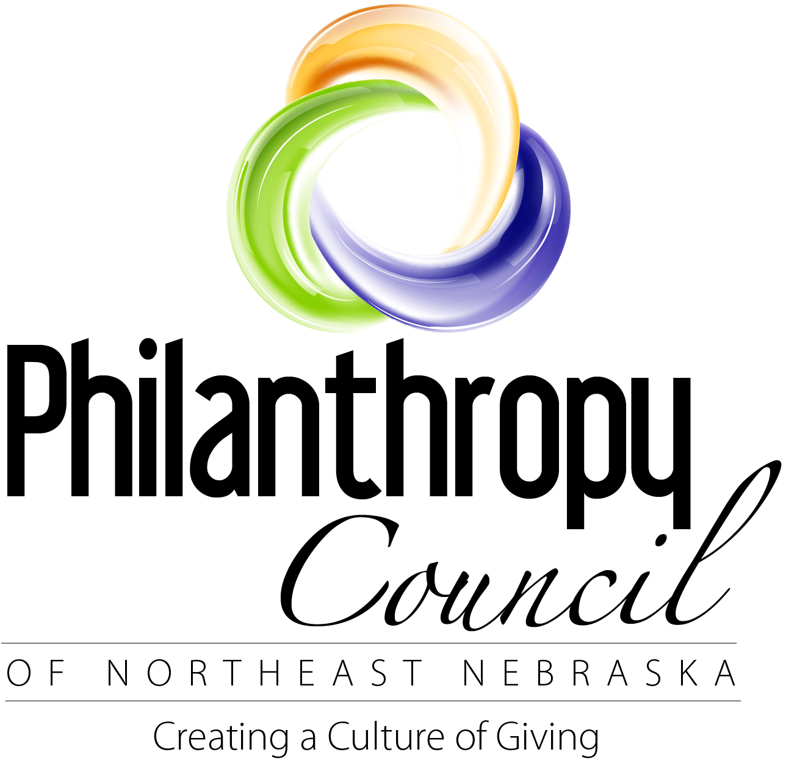
Philanthropy Awards
Individuals, businesses, or families that are doing, or have done, something outstanding in
our communities in the area of philanthropy.

A Philanthropy Award recognizes and honors individuals of all ages, businesses, or families who have been exceptional in their generosity in the following ways:
- Leading a current outstanding effort in the area of philanthropy.
- Giving gifts of time, talent and treasure that have made a significant contribution to the growth and success of our communities.
- Demonstrating outstanding civic and charitable responsibility by encouraging others to take philanthropic leadership roles.
- Previous winners include Julie Robinson (2013), Nucor Steel (2012), Steve and Karen Warner (2016), Jim Bradford, Jr. (2014), and The Zone Afterschool Program (2016). For a full list of previous winners please visit http://philanthropycouncilne.org/.

To nominate someone for this award, please complete the nomination form and submit
it to the Philanthropy Council of Northeast Nebraska by November 13, 2016 at
Attn: Philanthropy Awards, PO Box 714, Norfolk, NE 68702-0714 or submit via email to: awards@philanthropycouncilne.org.
Nomination forms will be retained for up to 3 years. Repeated nominations are welcomed, as there are often many deserving recipients nominated in a single year.

Nomination: ___________________________________________________________________
Street Address: _________________________________________________________________
City: _____________________________________ State: ____________ Zip: ________
Phone Number(s): ______________________________________________________________
E-mail Address: ______________________________________________________

Name of person submitting nomination: _____________________________________________
Street/Mailing Address: __________________________________________________________
City: _____________________________________ State: ___________ Zip: ________
Phone Number: ________________________________________________________________
E-mail Address: ________________________________________________________________
Describe why you think the nominee should be recognized with a Philanthropy Award. Provide examples and use additional space as needed.

